Transaction States in DBMS

A
ameya_chawla

• Read
• Discuss
• Courses

States through which a transaction goes during its lifetime. These are the states which tell about the current state of the Transaction and also tell how we will further do the processing in the transactions. These states govern the rules which decide the fate of the transaction whether it will commit or abort.
They also use Transaction log. Transaction log is a file maintain by recovery management component to record all the activities of the transaction. After commit is done transaction log file is removed.

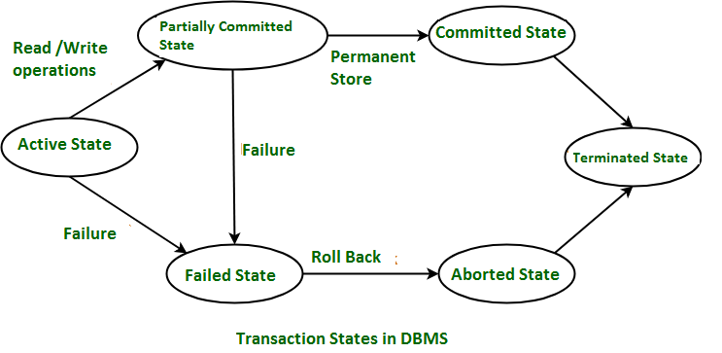
These are different types of Transaction States :

- Active State –
When the instructions of the transaction are running then the transaction is in active state. If all the ‘read and write’ operations are performed without any error then it goes to the “partially committed state”; if any instruction fails, it goes to the “failed state”.
- Partially Committed –
After completion of all the read and write operation the changes are made in main memory or local buffer. If the changes are made permanent on the DataBase then the state will change to “committed state” and in case of failure it will go to the “failed state”.
- Failed State –
When any instruction of the transaction fails, it goes to the “failed state” or if failure occurs in making a permanent change of data on Data Base.
- Aborted State –
After having any type of failure the transaction goes from “failed state” to “aborted state” and since in previous states, the changes are only made to local buffer or main memory and hence these changes are deleted or rolled-back.
- Committed State –
It is the state when the changes are made permanent on the Data Base and the transaction is complete and therefore terminated in the “terminated state”.
- Terminated State –
If there isn’t any roll-back or the transaction comes from the “committed state”, then the system is consistent and ready for new transaction and the old transaction is terminated.

Serializability in DBMS
The backbone of the most modern application is the form of DBMS. When we design the form properly, then it provides high-performance and relative storage solutions to our application. In this topic, we are going to explain the serializability concept and how this concept affects the DBMS deeply. We also understand the concept of serializability with some examples. Finally, we will conclude this topic with an example of the importance of serializability.

What is Serializability in DBMS?
In the field of computer science, serializability is a term that is a property of the system that describes how the different process operates the shared data. If the result given by the system is similar to the operation performed by the system, then in this situation, we call that system serializable. Here the cooperation of the system means there is no overlapping in the execution of the data. In DBMS, when the data is being written or read then, the DBMS can stop all the other processes from accessing the data.
In the MongoDB developer certificate, the DBMS uses various locking systems to allow the other processes while maintaining the integrity of the data. In MongoDB, the most restricted level for serializability is the employee can be restricted by two-phase locking or 2PL. In the first phase of the locking level, the data objects are locked before the execution of the operation. When the transaction has been accomplished, then the lock for the data object is released. This process guarantees that there is no conflict in operation and that all the transaction views the database as a conflict database.
The two-phase locking or 2PL system provides a strong guarantee for the conflict of the database.
It can reduce the decreased performance and then increase the overhead acquiring capacity and then release the lock of the data. As a result, the system allows the constraint serializability for better performance of the DBMS. This ensures that the final result is the same as some sequential execution and performs the improvement of the operation that is involved in the database.
Thus, serializability is the system's property that describes how the different process operates the shared data. In DBMS, the overall Serializable property is adopted by locking the data during the execution of other processes. Also, serializability ensures that the final result is equivalent to the sequential operation of the data.

What is a Serializable Schedule?
- In DBMS, the Serializable schedule is a property in which the read and write operation sequence does not disturb the serializability property. This property ensures that the transaction is executed automatically with the other transaction. In DBMS, the order of the serializability must be the same as some serial schedules of the same transaction.
- In DBMS, there are several algorithms available to check the serializability of the database. One of the most important algorithms is the conflict serializability algorithm. The conflict serializability algorithm is the ability to check the potential of the conflict in the database. When the two transactions access the same data, this conflict occurs in the database. If there is no conflict, then there is guaranteed serializability in the database. However, if there is a conflict occurs, then there is a chance of serializability.
- Another algorithm that is used to check the serializability of the database is the DBMS algorithm. With the help of the DBMS algorithm, we can check the potential mutual dependencies between two transactions. When the two transactions give the correct output, then mutual dependencies exist. When there are no mutual dependencies, then there is a guaranteed serializable in the database. However, if there are mutual dependencies, then there will be a chance of serializable.
- We can also check the serializability of the database by using the precedence graph algorithm. A precedence relationship exists when one transaction must precede another transaction for the schedule to be valid. If there are no cycles, then the serializability of schedules in DBMS is guaranteed. However, if there are cycles, the schedule may or may not be serializable. To understand different algorithms comprehensively, take the MongoDB Administration certification and get expert analysis on the concept of serializability in DBMS.

Types of Serializability
In DBMS, all the transaction should be arranged in a particular order, even if all the transaction is concurrent. If all the transaction is not serializable, then it produces the incorrect result.
In DBMS, there are different types of serializable. Each type of serializable has some advantages and disadvantages. The two most common types of serializable are view serializability and conflict serializability.

1. Conflict Serializability
Conflict serializability is a type of conflict operation in serializability that operates the same data item that should be executed in a particular order and maintains the consistency of the database. In DBMS, each transaction has some unique value, and every transaction of the database is based on that unique value of the database.
This unique value ensures that no two operations having the same conflict value are executed concurrently. For example, let's consider two examples, i.e., the order table and the customer table. One customer can have multiple orders, but each order only belongs to one customer. There is some condition for the conflict serializability of the database. These are as below.
- Both operations should have different transactions.
- Both transactions should have the same data item.
- There should be at least one write operation between the two operations.
If there are two transactions that are executed concurrently, one operation has to add the transaction of the first customer, and another operation has added by the second operation. This process ensures that there would be no inconsistency in the database.

2. View Serializability
View serializability is a type of operation in the serializable in which each transaction should produce some result and these results are the output of proper sequential execution of the data item. Unlike conflict serialized, the view serializability focuses on preventing inconsistency in the database. In DBMS, the view serializability provides the user to view the database in a conflicting way.
In DBMS, we should understand schedules S1 and S2 to understand view serializability better. These two schedules should be created with the help of two transactions T1 and T2. To maintain the equivalent of the transaction each schedule has to obey the three transactions. These three conditions are as follows.
- The first condition is each schedule has the same type of transaction. The meaning of this condition is that both schedules S1 and S2 must not have the same type of set of transactions. If one schedule has committed the transaction but does not match the transaction of another schedule, then the schedule is not equivalent to each other.
- The second condition is that both schedules should not have the same type of read or write operation. On the other hand, if schedule S1 has two write operations while schedule S2 has one write operation, we say that both schedules are not equivalent to each other. We may also say that there is no problem if the number of the read operation is different, but there must be the same number of the write operation in both schedules.
- The final and last condition is that both schedules should not have the same conflict. Order of execution of the same data item. For example, suppose the transaction of schedule S1 is T1, and the transaction of schedule S2 is T2. The transaction T1 writes the data item A, and the transaction T2 also writes the data item A. in this case, the schedule is not equivalent to each other. But if the schedule has the same number of each write operation in the data item then we called the schedule equivalent to each other.

Testing of Serializability in DBMS with Examples
Serializability is a type of property of DBMS in which each transaction is executed independently and automatically, even though these transactions are executed concurrently. In other words, we can say that if there are several transactions executed concurrently, then the main work of the serializability function is to arrange these several transactions in a sequential manner.
For better understanding, let's explain these with an example. Suppose there are two users Sona and Archita. Each executes two transactions. Let's transactions T1 and T2 are executed by Sona, and T3 and T4 are executed by Archita. Suppose transaction T1 reads and writes the data item A, transaction T2 reads the data item B, transaction T3 reads and writes the data item C and transaction T4 reads the data item D. Lets the schedule the above transaction as below.
- •
- T1: Read A → Write A→ Read B → Write B`
- •
- `T2: Read B → Write B`
- •
- `T3: Read C → Write C→ Read D → Write D`
- • `T4: Read D → Write D
Let's first discuss why these transactions are not serializable.
In order for a schedule to be considered serializable, it must first satisfy the conflict serializability property. In our example schedule above, notice that Transaction 1 (T1) and Transaction 2 (T2) read data item B before either writing it. This causes a conflict between T1 and T2 because they are both trying to read and write the same data item concurrently. Therefore, the given schedule does not conflict with serializability.

Lock-Based Protocol
In this type of protocol, any transaction cannot read or write data until it acquires an appropriate lock on it. There are two types of lock:
1. Shared lock:
- It is also known as a Read-only lock. In a shared lock, the data item can only read by the transaction.
- It can be shared between the transactions because when the transaction holds a lock, then it can't update the data on the data item.
2. Exclusive lock:
- In the exclusive lock, the data item can be both reads as well as written by the transaction.
- This lock is exclusive, and in this lock, multiple transactions do not modify the same data simultaneously.

There are four types of lock protocols available:

1. Simplistic lock protocol
It is the simplest way of locking the data while transaction. Simplistic lock-based protocols allow all the transactions to get the lock on the data before insert or delete or update on it. It will unlock the data item after completing the transaction.

2. Pre-claiming Lock Protocol
- Pre-claiming Lock Protocols evaluate the transaction to list all the data items on which they need locks.
- Before initiating an execution of the transaction, it requests DBMS for all the lock on all those data items.
- If all the locks are granted then this protocol allows the transaction to begin. When the transaction is completed then it releases all the lock.
- If all the locks are not granted then this protocol allows the transaction to rolls back and waits until all the locks are granted.
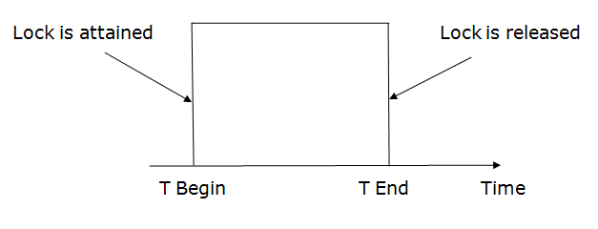

3. Two-phase locking (2PL)
- The two-phase locking protocol divides the execution phase of the transaction into three parts.
- In the first part, when the execution of the transaction starts, it seeks permission for the lock it requires.
- In the second part, the transaction acquires all the locks. The third phase is started as soon as the transaction releases its first lock.
- In the third phase, the transaction cannot demand any new locks. It only releases the acquired locks.
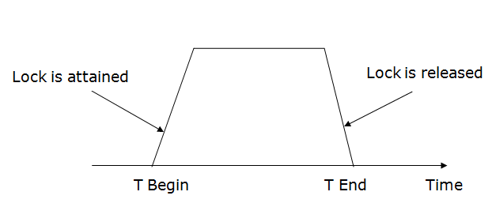
There are two phases of 2PL:
Growing phase: In the growing phase, a new lock on the data item may be acquired by the transaction, but none can be released.
Shrinking phase: In the shrinking phase, existing lock held by the transaction may be released, but no new locks can be acquired.
In the below example, if lock conversion is allowed then the following phase can happen:
- Upgrading of lock (from S(a) to X (a)) is allowed in growing phase.
- Downgrading of lock (from X(a) to S(a)) must be done in shrinking phase.
Example:
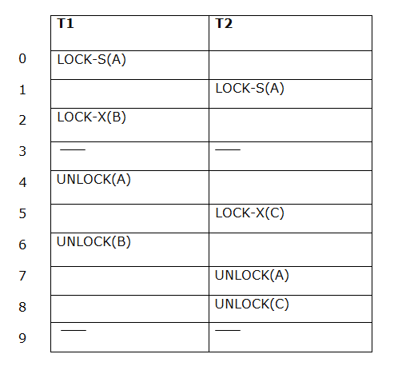
The following way shows how unlocking and locking work with 2-PL.
Transaction T1:
- Growing phase: from step 1-3
- Shrinking phase: from step 5-7
- Lock point: at 3
Transaction T2:
- Growing phase: from step 2-6
- Shrinking phase: from step 8-9
- Lock point: at 6

4. Strict Two-phase locking (Strict-2PL)
- The first phase of Strict-2PL is similar to 2PL. In the first phase, after acquiring all the locks, the transaction continues to execute normally.
- The only difference between 2PL and strict 2PL is that Strict-2PL does not release a lock after using it.
- Strict-2PL waits until the whole transaction to commit, and then it releases all the locks at a time.
- Strict-2PL protocol does not have shrinking phase of lock release.
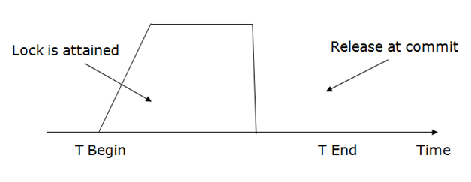
It does not have cascading abort as 2PL does.

Handling Deadlocks

A
ayush0x00

• Read
• Discuss
• Courses

Deadlock is a situation where a process or a set of processes is blocked, waiting for some other resource that is held by some other waiting process. It is an undesirable state of the system. The following are the four conditions that must hold simultaneously for a deadlock to occur.
- Mutual Exclusion – A resource can be used by only one process at a time. If another process requests for that resource then the requesting process must be delayed until the resource has been released.
- Hold and wait – Some processes must be holding some resources in the non-shareable mode and at the same time must be waiting to acquire some more resources, which are currently held by other processes in the non-shareable mode.
- No pre-emption – Resources granted to a process can be released back to the system only as a result of voluntary action of that process after the process has completed its task.
- Circular wait – Deadlocked processes are involved in a circular chain such that each process holds one or more resources being requested by the next process in the chain.
Methods of handling deadlocks: There are four approaches to dealing with deadlocks.
1. Deadlock Prevention
2. Deadlock avoidance (Banker's Algorithm)
3. Deadlock detection & recovery
4. Deadlock Ignorance (Ostrich Method)
These are explained below.
1. Deadlock Prevention: The strategy of deadlock prevention is to design the system in such a way that the possibility of deadlock is excluded. The indirect methods prevent the occurrence of one of three necessary conditions of deadlock i.e., mutual exclusion, no pre-emption, and hold and wait. The direct method prevents the occurrence of circular wait. Prevention techniques – Mutual exclusion – are supported by the OS. Hold and Wait – the condition can be prevented by requiring that a process requests all its required resources at one time and blocking the process until all of its requests can be granted at the same time simultaneously. But this prevention does not yield good results because:
- long waiting time required
- inefficient use of allocated resource
- A process may not know all the required resources in advance
No pre-emption – techniques for ‘no pre-emption are’
- If a process that is holding some resource, requests another resource that can not be immediately allocated to it, all resources currently being held are released and if necessary, request again together with the additional resource.
- If a process requests a resource that is currently held by another process, the OS may pre-empt the second process and require it to release its resources. This works only if both processes do not have the same priority.
Circular wait One way to ensure that this condition never holds is to impose a total ordering of all resource types and to require that each process requests resources in increasing order of enumeration, i.e., if a process has been allocated resources of type R, then it may subsequently request only those resources of types following R in ordering.
2. Deadlock Avoidance: The deadlock avoidance Algorithm works by proactively looking for potential deadlock situations before they occur. It does this by tracking the resource usage of each process and identifying conflicts that could potentially lead to a deadlock. If a potential deadlock is identified, the algorithm will take steps to resolve the conflict, such as rolling back one of the processes or pre-emptively allocating resources to other processes. The Deadlock Avoidance Algorithm is designed to minimize the chances of a deadlock occurring, although it cannot guarantee that a deadlock will never occur. This approach allows the three necessary conditions of deadlock but makes judicious choices to assure that the deadlock point is never reached. It allows more concurrency than avoidance detection A decision is made dynamically whether the current resource allocation request will, if granted, potentially lead to deadlock. It requires knowledge of future process requests. Two techniques to avoid deadlock :
- Process initiation denial
- Resource allocation denial
Advantages of deadlock avoidance techniques:
- Not necessary to pre-empt and rollback processes
- Less restrictive than deadlock prevention
Disadvantages :
- Future resource requirements must be known in advance
- Processes can be blocked for long periods
- Exists a fixed number of resources for allocation
Banker’s Algorithm:
The Banker’s Algorithm is based on the concept of resource allocation graphs. A resource allocation graph is a directed graph where each node represents a process, and each edge represents a resource. The state of the system is represented by the current allocation of resources between processes. For example, if the system has three processes, each of which is using two resources, the resource allocation graph would look like this:
Processes A, B, and C would be the nodes, and the resources they are using would be the edges connecting them. The Banker’s Algorithm works by analyzing the state of the system and determining if it is in a safe state or at risk of entering a deadlock.
To determine if a system is in a safe state, the Banker’s Algorithm uses two matrices: the available matrix and the need matrix. The available matrix contains the amount of each resource currently available. The need matrix contains the amount of each resource required by each process.
The Banker’s Algorithm then checks to see if a process can be completed without overloading the system. It does this by subtracting the amount of each resource used by the process from the available matrix and adding it to the need matrix. If the result is in a safe state, the process is allowed to proceed, otherwise, it is blocked until more resources become available.
The Banker’s Algorithm is an effective way to prevent deadlocks in multiprogramming systems. It is used in many operating systems, including Windows and Linux. In addition, it is used in many other types of systems, such as manufacturing systems and banking systems.
The Banker’s Algorithm is a powerful tool for resource allocation problems, but it is not foolproof. It can be fooled by processes that consume more resources than they need, or by processes that produce more resources than they need. Also, it can be fooled by processes that consume resources in an unpredictable manner. To prevent these types of problems, it is important to carefully monitor the system to ensure that it is in a safe state.
3. Deadlock Detection: Deadlock detection is used by employing an algorithm that tracks the circular waiting and kills one or more processes so that the deadlock is removed. The system state is examined periodically to determine if a set of processes is deadlocked. A deadlock is resolved by aborting and restarting a process, relinquishing all the resources that the process held.
- This technique does not limit resource access or restrict process action.
- Requested resources are granted to processes whenever possible.
- It never delays the process initiation and facilitates online handling.
- The disadvantage is the inherent pre-emption losses.
4. Deadlock Ignorance: In the Deadlock ignorance method the OS acts like the deadlock never occurs and completely ignores it even if the deadlock occurs. This method only applies if the deadlock occurs very rarely. The algorithm is very simple. It says ” if the deadlock occurs, simply reboot the system and act like the deadlock never occurred.” That’s why the algorithm is called the Ostrich Algorithm.
Advantages:
- Ostrich Algorithm is relatively easy to implement and is effective in most cases.
- It helps in avoiding the deadlock situation by ignoring the presence of deadlocks.
Disadvantages:
- Ostrich Algorithm does not provide any information about the deadlock situation.
- It can lead to reduced performance of the system as the system may be blocked for a long time.
- It can lead to a resource leak, as resources are not released when the system is blocked due to deadlock.

